 | 

Child Guard: GPS Location Tracking Mobile App

A Report Submitted to the Council of
the College of Science at the University of Sulaimani in Partial Fulfillment of the Requirements
for the Bachelor of Science in Computer Science

by
Zhiwar Mohammed Fatah Rekan Awat Mohammed Dyako Murad Ali
Savo Haider Jabar

Supervisor Full name
Dr. Mohammed Qadir Kheder

May, 2024 (English) Cozerdan, 2724 (Kurdish)

Dedication

We dedicate this research especially to our parents for their assistance in reaching this level of education. And also, to our supervisor teacher (Mohammed Q. Kheder) for his guidance throughout the whole process. Finally, we dedicate this research to all the teachers and students, and researchers at the University of Sulaimani.

Acknowledgments

First, thank God for providing us with everything we needed to complete this project. We put in lots of effort to get the project completed on time. However, it would not have been possible without the kind support and help of many individuals and dear friends. We are highly indebted to the teacher in charge Mr. Mohammed Q. Kheder for his guidance and constant supervision as well as for providing necessary information regarding this project and his support in completing it, it is highly appreciated. Completing this project helped me learn many new skills. Second, we would like to thank our parents and dear friends who assisted us a lot in finalizing this project within the limited time frame.

Zhiwar Mohammed Fatah Rekan Awat Mohammed Dyako Murad Ali
Savo Haider Jabar

June 2, 2024

Abstract
ChildGuard, a groundbreaking mobile application, seamlessly integrates advanced Global Positioning System (GPS) technology to prioritize child safety. Offering real- time monitoring and heightened security, parents gain instant updates on their child's location, instilling a profound sense of security. The app goes further with cutting- edge GPS tracking, enabling parents to receive immediate notifications and access a comprehensive location history log for in-depth reviews of their child's movements over specific periods. With an intuitive and user-friendly interface, ChildGuard actively fosters communication and trust between parents and children, responding to the challenges of parenting in today's interconnected world. Designed with a commitment to safety, ChildGuard harnesses the power of GPS technology to provide a range of features ensuring continuous real-time monitoring and enhanced security. Parents can count on receiving instant updates on their child's location through the app's cutting-edge GPS tracking capabilities. Moreover, the application goes beyond, offering a detailed location history log that empowers parents to review and understand their child's movements over specific periods. The user-friendly design aims to establish a sense of security, trust, and open communication between parents and their children, effectively addressing the complexities of parenting in our interconnected world.

Table of Contents

Dedication ii
Acknowledgments iii
Abstract iv
List of Abbreviations viii
Chapter 1 1
Introduction 1
  - Introduction 1
  - Problem Statement 3
  - Background and Literature Review 3
    - Literature review 3
    - Methodology 6
      - Research Methodology 6
    - Software Development Methodology 7
      - Iterative Model 7
    - Requirements 10
      - Database System 10
      - Computer Programming Language 11
      - Software and Tools 13
  - The Aims of the Project 14
  - Report Layout 15
Chapter 2 17
Design and Implementation 17
  - Introduction 17
  - Project Design 17
    - Unified Modeling Language 17
      - Flow Chart 18
      - Use Case 19
      - Activity Diagram 20
      - Rich Picture 21
      - Sequence Diagram 22
    - Project Implementation 22
Chapter 3 30
Conclusions and Future Directions 30
  - Introduction 30
  - Conclusions 30
  - Future Directions 30
…………………………………………………………………………………………………………………………………………………………32پوختە
Bibliography 33

Table of Figures
Figure 1: Iterative Process Model 10

Figure 2: Cloud Firestore. 11

Figure 3: Flutter & dart 12

Figure 4: Open Street Map 14

Figure 5: Flow Chart Diagram 18

Figure 6: Use Case Diagram 19

Figure 7: Activity Diagram 20

Figure 8: Rich Picture 21

Figure 9: Sequence Diagram 22

Figure 10: Child Guard Application Icon 22

Figure 11: Splash interface 23

Figure 12: Parent or Child interface 23

Figure 13: Login interface 24

Figure 14: Sign Up interface 24

Figure 15: Parent Dashboard interface 25

Figure 16: Parent interface 25

Figure 17: Map interface 26

Figure 18: Tracking Map interface 26

Figure 19: Chat interface 27

Figure 20: Alert Messages interface 27

Figure 21: Child Dashboard interface 28

Figure 22: Child Settings interface 28

List of Abbreviations

A/D | A/D Analog-To-Digital | DNI | DNI Direct Neural Interface
API | Application Programming Interface | OSM | OpenStreetMap
DBMS | Database Management System | SDK | Software Development Kit
DGPS | Differential Global Positioning System | SGT | Sergeant
FCD | Floating Car Data | SMS | Short Message Service
GSM | Global System for Mobile Communications | UI | User Interface
GPS | Global Positioning System | UX | User Experience
IOS | iPhone Operating System | UML | Unified Modeling Language
LBS | Location-Based Services | VS code | Visual Studio Code

Chapter One Introduction

  - Introduction

Chapter 1

Introduction

In today's world, over 80% of the global population, including children as young as seven or eight, own smartphones [1]. In an era marked by rapid technological advancements, the safety and well-being of our children have become paramount concerns for parents and guardians [2]. Among the digital solutions addressing these concerns, the Child Guard Global Positioning System (GPS) stands out as a notable innovation. This cutting-edge technology harnesses the power of the GPS and tracking capabilities to provide parents with real-time insights into the whereabouts of their children [3]. As we navigate a world where the security of our loved ones remains a constant priority, Child Guard GPS emerges as a reassuring ally. This comprehensive tracking system is designed to offer parents peace of mind by enabling them to monitor their children's locations with precision and efficiency. Whether during the daily commute to school, participation in extracurricular activities, or simple neighborhood explorations, Child Guard GPS acts as a virtual guardian, keeping parents connected and informed. Child Guard goes beyond traditional location tracking by implementing a unique feature known as real-time updates. This feature enables parents to receive notifications instantly, providing insight into their child's exact location at any given moment. Whether the child is at school, a friend's house, or engaged in extracurricular activities, parents can stay informed minute by minute, fostering a heightened sense of security and control. The integration of Flutter, Firebase, and OpenStreetMap forms a dynamic cross-platform solution for robust location-based services, catering to both Android and iPhone Operating System (iOS). Flutter's single codebase ensures a consistent and efficient user experience across diverse devices, while Firebase enhances security and
responsiveness through real-time data synchronization and authentication. By

leveraging Flutter's geolocation packages and Firebase Cloud Firestore, developers can implement precise location tracking, enriching the application with real-time updates and customizable maps for an immersive user experience. In addition to its robust tracking features, Child Guard GPS enhances parent-child communication with secure chat functionality. This feature allows parents and children to exchange messages within a safe, encrypted environment, ensuring that all communications are as secure as the location data. This not only aids in maintaining regular contact but also provides a direct line of communication in case of emergencies, further boosting the system’s safety protocols and giving parents additional peace of mind. Child Guard GPS also offers a historical tracking feature that provides a comprehensive overview of a child’s movements over a specific period. This functionality is crucial for understanding a child’s routines, identifying patterns, and promptly addressing any deviations from the norm. Parents can access a detailed log of their child’s locations, making informed decisions based on their daily activities. As technology intertwines more deeply with our daily lives, concerns about privacy and security naturally arise. Child Guard GPS addresses these concerns by implementing robust encryption protocols and secure data storage mechanisms. Sensitive information, such as a child's location data, is safeguarded against unauthorized access, ensuring that only authorized individuals, typically the parents or guardians, can monitor their child’s whereabouts. This commitment to privacy and security is essential in building trust between parents and the technology that plays a pivotal role in their child's safety. GPS tracking can be a handy feature as you allow your kids to have more independence, or it can simply provide peace of mind in special situations, such as during a visit to a large, crowded amusement park. With some gadgets, you can also set up notifications that alert you if your child has left or arrived at a particular location [4]. Research in Malaysia shows that missing children are primarily classified into two categories: disappearances, including running away from home,

and abductions or kidnappings. Statistics reveal that since 2004, a total of 5,996 children under the age of 18 went missing from their homes [5].

Problem Statement
In today's fast-paced and increasingly digitalized world, ensuring the safety of children is a top priority for parents. As children explore their surroundings, attend school, and engage in various activities, parents often face challenges in keeping track of their whereabouts. The lack of an efficient and user-friendly real-time child guard location tracking system poses a significant concern for parents who want to ensure the safety of their children. The primary objective of this research is to develop an advanced, real-time child guard location tracking system that offers precise and instantaneous location updates to parents. The system should be intuitive, secure, and adaptable to various scenarios, providing parents with a comprehensive tool to enhance child safety. With the advent of technology, there is a growing need for such a reliable system that empowers parents to monitor their children's movements seamlessly. Existing solutions may be cumbersome, inaccurate, or lack essential features, creating a gap in providing parents with the necessary tools to monitor and safeguard their children effectively.

Background and Literature Review

Literature review
The Emerging Ethics of Humancentric GPS Tracking and Monitoring Both private and public enterprises are now using the GPS for tracking and monitoring humans through location-based services (LBS). These services include personal locators for children, the elderly, or those suffering from Alzheimer's or memory loss, and the monitoring of parolees for law enforcement, security, or personal protection. With the continuous miniaturization of the GPS chipset, devices such as wristwatches, mini mobiles, and bracelets are now capable of pinpointing the longitude and latitude of a

person 24/7/365. This paper utilizes usability context analyses to identify the emerging ethical concerns regarding current human-centric GPS applications. The study categorized the current state of GPS applications into three contexts: control, convenience, and care. It also proposes a preliminary ethical framework for considering the viability of GPS location-based services that emphasize privacy, accuracy, property, and accessibility [6]. Tracking living beings and devices using the GPS has become prevalent and indispensable over the last few years. Applications range from military and national security to personal safety and comfort. This paper reviews some of the recent application areas and discusses the benefits and issues of GPS tracking. It then presents a software architecture of a general tracking system to locate lost and misplaced devices (and those that carry such devices) [7]. GPS tracking has many uses in today's world; the system can be used for children tracking, assets, cars, or any equipment tracking, and as spy equipment. This paper presents an accurate and reliable real-time tracking system using GPS and GSM (global system for mobile communication) services, which was designed and implemented successfully in the University of Khartoum labs. The system permits the localization of a portable tracked unit and transmitting the position to the tracking center. The GPS tracking system consists of a portable tracked device attached to a person, vehicle, or any asset, and the tracking center where the portable device's location should be monitored. The mobile tracked device receives its coordinates from the GPS and sends these coordinates as SMS (short message service) via GSM modem to the tracking center, which is simply a personal computer with many interface programs to display the location on Google Maps using a free version of Google Maps APIs (application programming interfaces). The testing shows that the system meets its objective of being low-cost, accurate, real-time, and adaptive for various applications [8]. This research note describes the methodological and practical applications of using smartphone GPS tracking (SGT) to explore the spatial distribution and density of recreational movement in multiple-use urban forests. We

present findings from the pilot phase of an ongoing case study in Keskuspuisto (Central Park), Helsinki, Finland. The study employs an inventive and inexpensive approach for participatory data collection i.e. gathering GPS data from recreational users who have already recorded their routes for purposes other than research, using any kind of sports tracking application on their mobile phones. We used the SGT data to examine visitor spatial patterns on formal trails and informal paths, and present examples with runners and mountain bikers. Hotspot mapping of mountain bikers’ off-trail movement was conducted identifying several locations with clustering of off-trail use. Small-scale field mapping of three hotspot areas confirmed that the method accurately located areas of high-use intensity where visible effects of path widening and high levels of wear on the forest floor vegetation could be observed. We conclude that the SGT methodology offers great opportunities for gathering useful and up-to-date spatial information for adaptive planning and management as it highlights areas where conservation and visitor management measures may need to be adjusted. We suggest that this method warrants testing also for other user- centered research and planning purposes [9]. GPS (Global Positioning System) has a variety of applications among which real-time tracking finds significance in day-to- day life. GPS tracking is defined as the measurement of object position and orientation in a given coordinate system using GPS data at different points in time. GPS data are collected from GPS receivers attached to the moving objects and these data are used for tracking objects in real-time. Researchers who work in GPS tracking need GPS databases which contain a huge volume of GPS data generated by hundreds of GPS receivers. However, the presently available GPS databases are owned by private players and are not available for use by the researchers. This work is an attempt to generate a database of GPS data that can be used by researchers to develop and test GPS applications. The approach consists of three successive steps: Collecting floating car data (FCD) of each path once in a log file; refining the log file; and replaying multiple instances of several log files simultaneously after replacing some

old values with new values to simulate GPS tracking. Thus, a single path tracked previously can be used to produce a tracking simulation of several moving objects by path replaying and every execution of the simulation generates a set of new GPS tracking data of several moving objects. These data are stored in a database and can be used as sample data for developing and testing GPS applications [10]. In recent decades, traffic congestion has been a serious problem that affects people both economically as well as mentally. The proposed system is to analyze and monitor traffic congestion with mobile phones and use GPS data for Public Transport Planning. The accurate traffic data to estimate is extracted by the B+ tree. This system that works with RPA and KNN provides an accurate map for more efficient estimation results for traffic state and saves time [11].

Methodology
Methodology is a systematic method used to analyze, understand, and principles associated with a field of study. According to [12, 13, 14], it is a useful way to understand the theoretical aspect of the problem, not to find its solution practically, but to choose the best method for specific situations [12].

Research Methodology
A child monitoring application integrates qualitative and user-centered design approaches, meticulously structured into a series of phases to maximize its effectiveness and user-friendliness. This extensive approach ensures that every aspect of the app is developed with a focus on real user needs and preferences, enhancing the overall experience and functionality.
- Planning and Requirements Gathering: Define the application's objectives and target audience. Conduct interviews and surveys with potential users to understand their needs, leading to a detailed requirements specification.

- Design: Develop initial UI/UX design prototypes, engage target users for feedback, and refine the designs based on their input to ensure the app is intuitive and easy to use.
- Development: Code the specified features, conducting iterative testing throughout this phase to ensure functionality and seamless integration.
- Testing and Validation: Perform comprehensive testing, including functional, usability, and security testing, to ensure the app works correctly and safely across different devices.
- Deployment: Release a beta version to a limited audience for real-world testing, make final adjustments based on feedback, and then officially launch the app on various platforms.
- Post-Launch Monitoring and Updates: Provide ongoing user support and regularly update the app based on user feedback and technological advancements to enhance functionality and user experience.

Software Development Methodology
Software development methodology refers to the structured processes used in creating software, including various phases like design and development. One such approach is the iterative process, which breaks the development into repeated cycles for continuous refinement, contrasting with the linear, non-iterative waterfall model. This allows software projects to evolve with ongoing feedback and changing requirements.

Iterative Model
In the iteration model at the beginning of creating each software information and complete software are not in our hands, the beginning plan of the model is collecting simple and small requirements to create software then step by step adding and

developing the software, in which team members discussed to jump to next step. Step by step by adding each version the previous step starts to develop and the software gets wider. Adding each part revision to the design and previous software information happens in the form of cycle shape adding and continuous changes in this model until we gain the result. [15]

Why use an iterative model
Using an iterative model in such contexts can offer several benefits. Here’s how it generally works and why it’s particularly useful:

Continuous Improvement
Iterative models facilitate ongoing enhancements by addressing risks and flaws early through feedback during each phase, crucial for child safety products like monitoring apps or car seats.

Adaptability to Change
The iterative approach enables easy adaptation to evolving children's needs and safety regulations by integrating new insights and compliance requirements without major overhauls.

Stakeholder Engagement
Involving stakeholders such as parents and safety experts ensures that products meet diverse needs and expectations, enhancing alignment and efficacy in child safety solutions.

Risk Management
Iterative models break projects into manageable parts, allowing early detection and mitigation of risks, reducing overall threats, and preventing potential costly recalls.

Learning and Innovation
Each cycle in the iterative process promotes exploration and learning from previous iterations, driving innovation that leads to more effective child safety solutions.

Better Resource Allocation
Dividing projects into phases allows for a more efficient allocation of resources, focusing on prioritizing and refining key safety features as needed.

Higher Quality Outcome
Regular testing and revisions in the iterative process catch issues early, ensuring the final product meets stringent safety and usability standards for children.

Implementation Phases
  - Initial Planning Defining project scope, goals, and timelines. Identifying stakeholders and their roles.
  - Planning Developing A detailed project plan, including resource allocation and risk management.
  - Requirements Gathering and documenting user needs, expectations, and constraints.
  - Analysis & Design Breaking down requirements into smaller components and creating a detailed design of the solution.
  - Implementation Building the solution according to the design, using the allocated resources.
  - Testing Verifying that the solution meets the requirements and works as expected.
  - Evaluation Assessing the solution's quality, performance, and effectiveness in meeting user needs.

  - Development The entire iterative process of planning, requirements, analysis, design, implementation, testing, and evaluation.
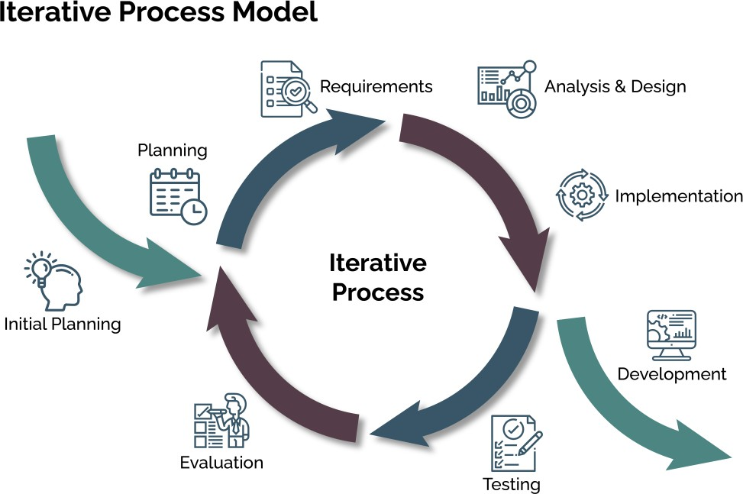

Figure 1: Iterative Process Model

Requirements

Database System
A database is an electronically stored, systematic collection of data. It can contain any type of data, including words, numbers, images, videos, and files. You can use software called a database management system (DBMS) to store, retrieve, and edit data [30]. They use query languages like SQL for data interaction and maintain data integrity through enforced constraints. Types of databases include relational systems like MySQL and PostgreSQL, and NoSQL systems like MongoDB and Cloud Firestore, each suited to different needs [16, 17]. Managed by a Database Management System (DBMS), databases are crucial for applications ranging from websites to complex enterprise systems [16].

Cloud Firebase
Cloud Firestore, part of the Google Firebase platform, is a cloud-based NoSQL database that supports the storage and synchronization of data in real-time. It allows direct interactions via native SDKs for web and mobile apps and supports a variety of technologies like Java, C++, Unity, and Node.js. Integrating Firestore along with other Firebase Cloud services like Realtime Database, Authentication, Cloud Functions, Cloud Messaging, and Cloud Storage provides a robust backend for child guard projects. These services facilitate real-time storage and retrieval of location data, secure user authentication, server-side logic execution, and real-time communication via push notifications. Additionally, Firebase offers tools for analytics and security management, enhancing user engagement and system security. This comprehensive suite of services is ideal for building scalable and secure location tracking systems for monitoring children [17].

Figure 2: Cloud Firestore

Computer Programming Language
Programming languages serve as a bridge between human thought and computer execution, translating human-readable instructions into binary code that computers can process. They are formalized sets of instructions comprising syntax and semantics, which dictate how code is written and executed. Programming languages range from low-level, like Assembly, to high-level, like Python and Java, each designed for specific tasks and varying in complexity. These languages enable the creation of software and applications, allowing programmers to write algorithms, perform logical operations, and manipulate data. Tools such as compilers and

interpreters convert this code into machine-readable instructions, making programming languages indispensable for software development [18].

Dart Programming Language
Dart is an open-source, general-purpose programming language developed by Google in 2011 with a C-style syntax and strong typing. Originally designed for frontend development of web and mobile apps, Dart is compiled into native machine code, enhancing performance across platforms. It supports object-oriented concepts like classes and interfaces but uniquely handles collections instead of traditional arrays, accommodating structures like generics. Dart is integral to developing responsive applications such as child guard systems, leveraging its integration with Firebase for robust real-time communication and data management. The language supports asynchronous operations, facilitating efficient handling of concurrent tasks, which is vital for real-time tracking and user authentication in safety-critical applications. Its compatibility with Flutter’s extensive widget library and potential for expansion into web and desktop applications make Dart a versatile tool in cross- platform development. Dart’s community-driven improvements and straightforward syntax contribute to its accessibility and reliability in software development [19].



Figure 3: Flutter and Dart

Software and Tools

Visual Studio code
Visual Studio Code, commonly known as VS Code, is a lightweight, open-source code editor developed by Microsoft, available for Windows, Linux, macOS, and web browsers. It is designed to provide a simple yet highly customizable coding environment, distinguishing itself from full-fledged IDEs by focusing on extensibility and ease of use. VS Code supports a variety of programming languages and offers features such as debugging, syntax highlighting, intelligent code completion, snippets, code refactoring, and Git integration. Users can personalize the interface with themes, keyboard shortcuts, and preferences, and can enhance functionality through numerous extensions. Its integrated terminal and debugging tools, coupled with a strong community and regular updates, contribute to its popularity and effectiveness in collaborative development projects [20].

Flutter SDK
Flutter is Google’s free, open-source software development kit (SDK) used for cross- platform application development. It allows developers to build natively compiled applications for mobile, web, and desktop platforms from a single codebase, using the Dart programming language. Flutter is known for its high performance and scalability, providing a rich set of customizable widgets that help create visually appealing and functional user interfaces. The SDK supports Android and iOS, emphasizing features like hot reload for quick development iterations and a reactive framework that ensures a consistent user experience across all platforms. Its efficiency and ability to produce aesthetically pleasing, responsive applications have made Flutter the most popular cross-platform mobile SDK among developers [21].

Open Street Map (OSM)
OpenStreetMap (OSM) is a free, editable global map initiated in 2004 in the UK, created and maintained by a worldwide community of contributors. This collaborative project was started out of a need for accessible, high-quality map data. OSM allows users to update and add geographic information, offering a dynamic and detailed representation of the world's features. The platform supports diverse applications, from disaster response and urban planning to research, by allowing customization and integration through APIs. Its open data principles ensure accessibility and versatility, with data available in vector format for flexibility in usage. The community-driven model of OSM not only ensures the map's continual improvement and accuracy but also exemplifies the effectiveness of crowdsourcing in creating and maintaining comprehensive global mapping data [22].



Figure 5: Open Street Map

The Aims of the Project

Enhanced Child Safety
Develop a GPS tracking system to provide real-time location monitoring of children, ensuring parents have immediate access to their whereabouts.

User-Friendly Interface
Create an intuitive and user-friendly mobile application interface for parents to easily track and manage the GPS monitoring of their children.

Privacy and Security
Prioritize the privacy and security of children by implementing robust encryption protocols and access controls to safeguard sensitive location data.

Report Layout
The rest of the report is organized as follows:

Chapter Two:
In this chapter, various types of designs were important to the development of the product of this final year BSc project. It gives screen designs for each page of the application, and it also presents types of UML diagrams that have been used to design the application. Moreover, chapter two gives the reader an overview of the implementation of the application.

Chapter Three:
The final chapter of this report paper gives the reader a summary of the report, and the future works of our group on the application to improve and maintain it.

Chapter Two Design and Implementation

  - Introduction

Chapter 2

Design and Implementation

This chapter delves into the design of the product, offering detailed screen designs for each page. It also explores various types of UML diagrams that assist in product development. Furthermore, the chapter includes an overview of the product's implementation, providing concise information for each page.

Project Design
Project design is one of the earliest stages in the life of a project (exactly when it occurs varies by organization). It will help ensure important details are included, and that your project is realistic and achievable.

Unified Modeling Language
UML is a standardized modeling language consisting of an integrated set of diagrams, developed to help system and software developers specify, visualize, construct, and document the artifacts of software systems, as well as for business modeling and other non-software systems [23]. The UML represents a collection of best engineering practices that have proven successful in the modeling of large and complex The UML uses mostly graphical notations to express the design of software projects. Using the UML helps project terms communicate, explore potential designs, and validate the architectural design of the software, in this article, we will give you detailed ideas about what is UML, its history, and a description of each UML diagram type. Along with UML examples.

Flow Chart
A flowchart is a graphical representation of documenting a sequence of operations. The following diagram shows the flowchart of the proposed system [23].

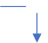
Start

Parent
Choose

Child NO
Child
Paren or Child Selected

Parent

Yes

Have Account

Yes

Which One
Enter
Email and Password

NO

if logged in

Login
Parent Child
Login

False
No

Sign Up

False
Enter
Email and Password
Create
Email and Password

False

Check email
and password

Check email
and password

True

Child Dashboard

True

Parent
Dashboard
Check
Validation

Parent

Which One

Child

Yes

choose choose

Logout

Settings

Map

Tracking

Chat
Danager Button
Message
Set
Location
Update
Location

Chat
Danger
Button
Logout

Generate Security Code

Real time Child Location

Show the tracking and child location

Send Message & Delete Message

Show Danager Button Message
Accept location permission
Update the child location

Send Message
Send Dnager Message to Parent
Enter Security Code

False

End

True
Check Security
Code

Figure 5: Flow Chart Diagram

Use Case
A use case is a description of how a user interacts with a system to achieve a specific goal. It outlines the steps or scenarios under which a system responds to a user's needs, emphasizing the interaction between the user and the system. Use cases are essential in functional requirements gathering and system design [23]. They help identify the system's functionalities from the user's perspective, ensuring that all user requirements are captured accurately. By detailing each interaction, use cases provide a clear understanding of user expectations and system behavior. They also serve as a foundation for developing test cases, ensuring thorough testing against real-world scenarios. Additionally, use cases facilitate communication among stakeholders, developers, and testers, promoting a shared understanding of system requirements and functionalities.

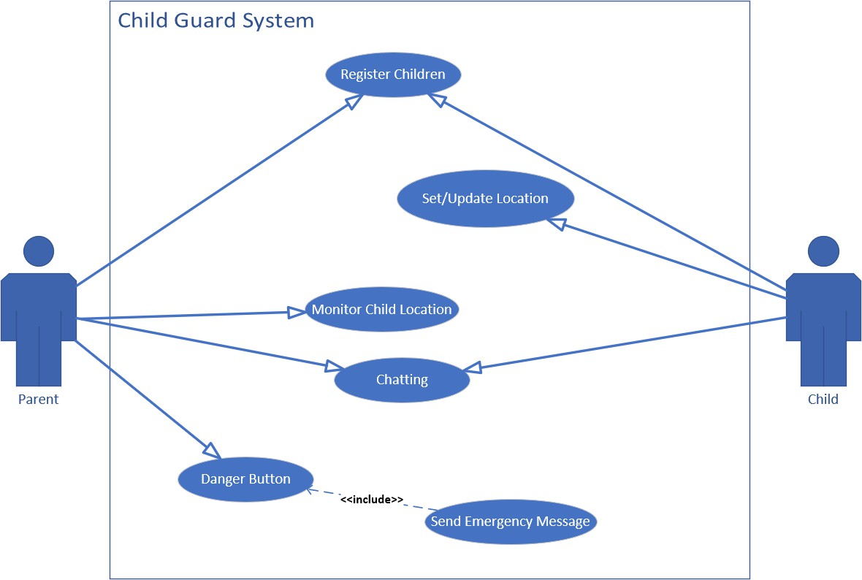

Figure 6: Use Case Diagram

Activity Diagram
An activity diagram is a type of UML diagram that illustrates the dynamic aspects of a system by modeling its workflow and operational sequences. It shows the flow of control from one activity to another, capturing both sequential and parallel activities. This diagram is particularly useful for visualizing the process flows within a system [23].
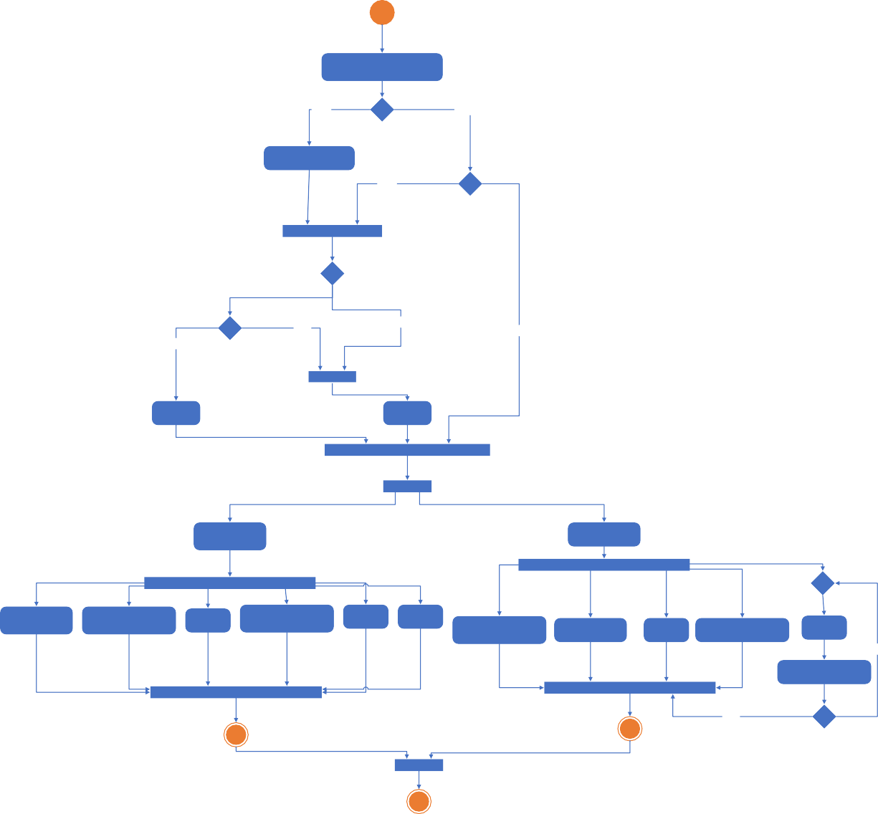
Check If Parent or Child
Selected
False
True
is Selected?
select Parent or Child
False
is Logged in?
Parent
Child
True
True
False
Have Account?
Sign up
Login
Parent
Child
Parent
Dashboard
Child Dashboard
Show Child
Location
Show tracking
Location
Chatting
Danger Button
Messages
Settings
Logout
Enable Location
Permission
Update Location
Chatting
Danger Button
Logout
False
Enter Private Code
True
is Correct?

Figure 7: Activity Diagram

Rich Picture
A rich picture is a tool used in systems thinking to explore, acknowledge, and visually represent the complex relationships, processes, and interactions within a system. It allows stakeholders to communicate issues, conflicts, and connections in an informal, illustrative manner. Rich pictures help in understanding the big picture without getting lost in detailed documentation [23].
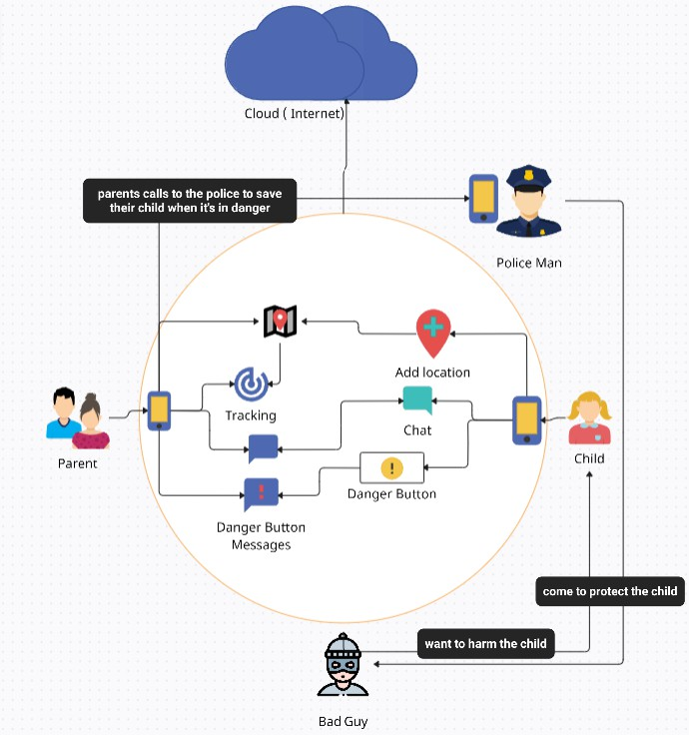
Figure 8: Rich Picture

Sequence Diagram
A sequence diagram is a type of UML diagram that shows how objects interact in a particular scenario of a use case, detailing the order of messages exchanged among them. It helps in visualizing the sequence of operations in system functionalities or processes [23].
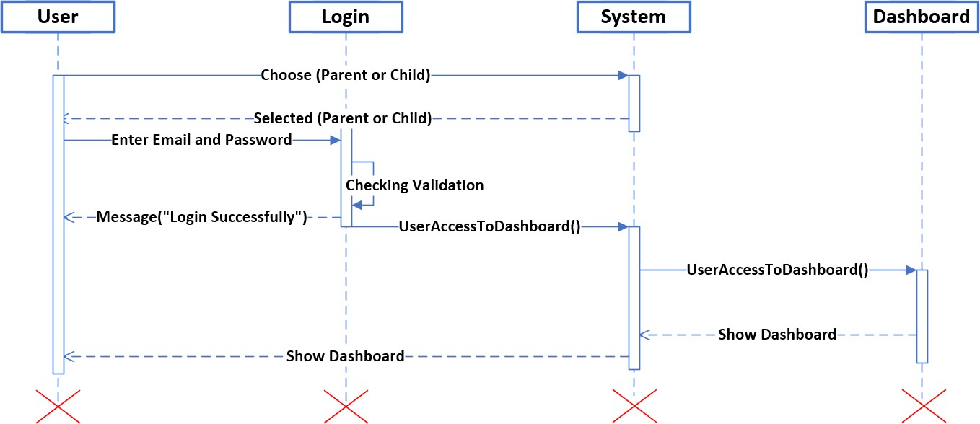

Figure 9: Sequence Diagram

Project Implementation

2.2.3 Implementing Child Guard involves creating a user-friendly mobile app with advanced GPS tracking and real-time updates for child safety.


Figure 10: Child Guard Application Icon

The Splash Screen is the first screen you seen when you open the application. The second screen is used to select whether you want to become the parent or the child.


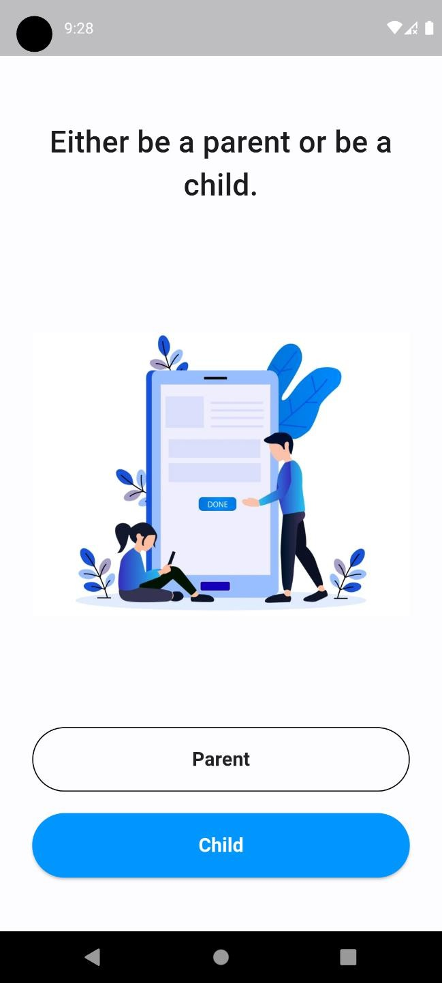
Figure 11: Splash interface Figure 12: Parent or Child interface

After selecting the parent or child, you will see the login screen. You need to log in first to use the features of the application. If it's your first time using this application, you should first register an account (from the parent option only).
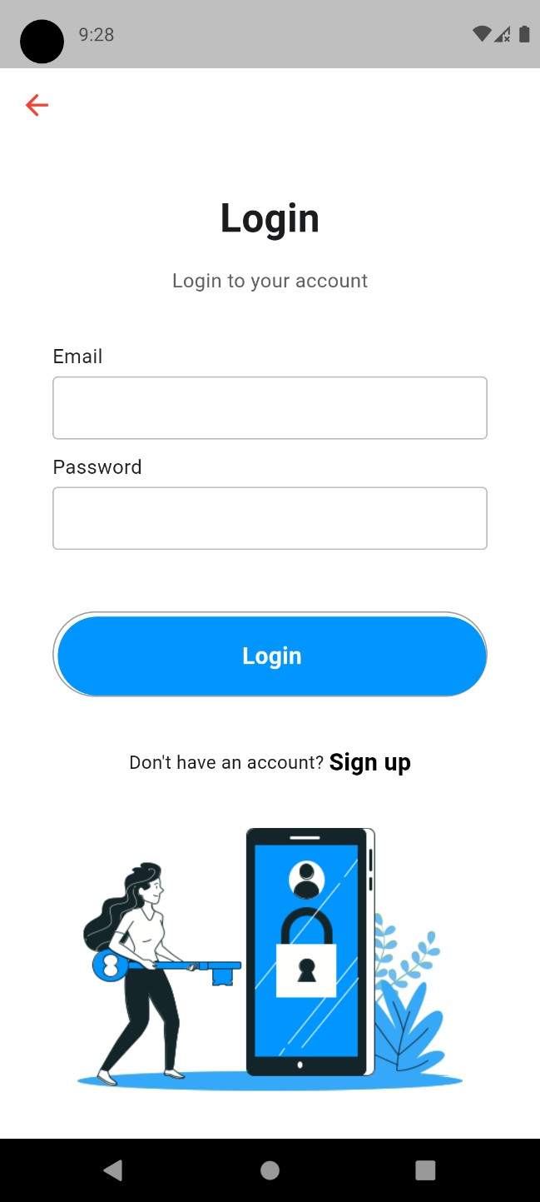
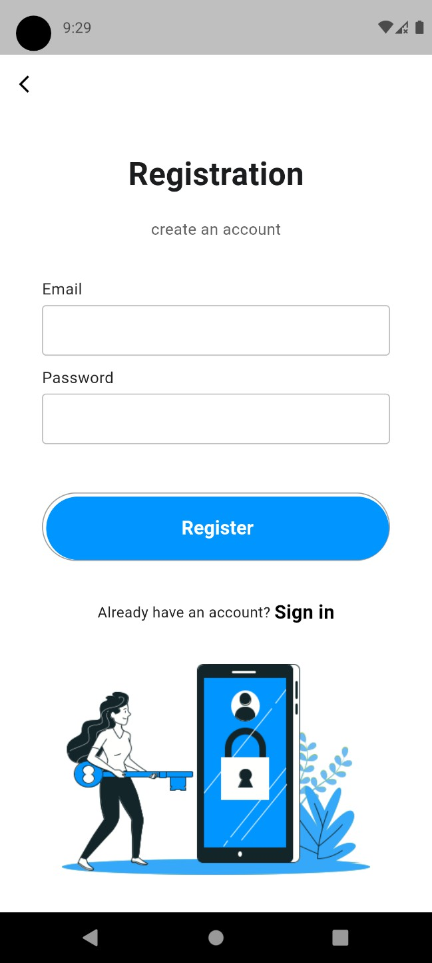
Figure 13: Login interface Figure 14: Sign up interface

The Dashboard of the Parent Option contains the following features: a map where you can see the real-time location of the child, a Tracking Map used to view the history of locations visited by the child, a chat feature for communicating with the child, and Recent Alerts which contain all alert messages that come from the child's device. The settings are used to randomly generate a code that you need in order to log out from the child's dashboard; without this code, you cannot log out.
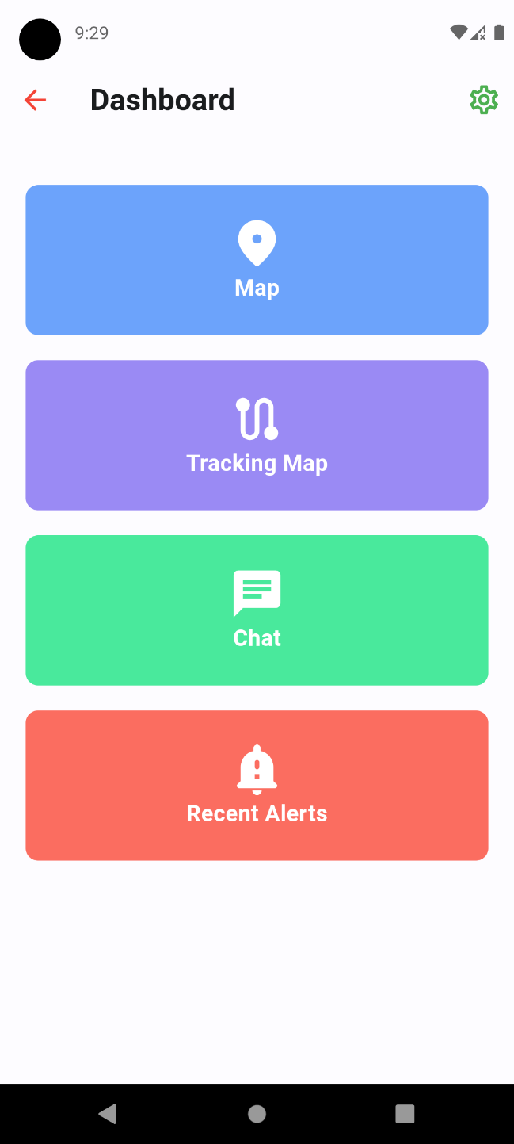
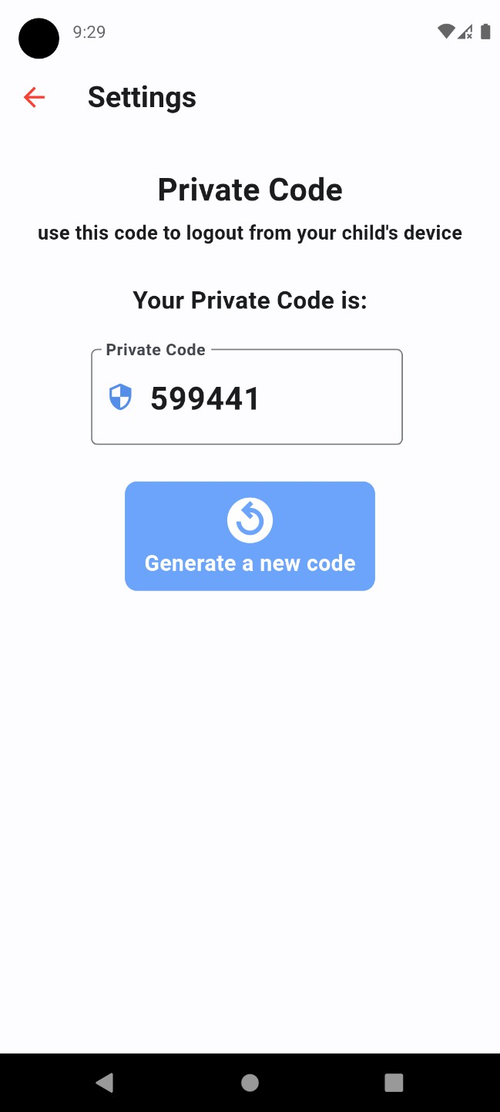
Figure 15: Parent Dashboard interface Figure 16: Parent interface

The map used is OSM, which displays the real-time location of the child. The tracking feature can save the locations visited by the child for up to 8 days.
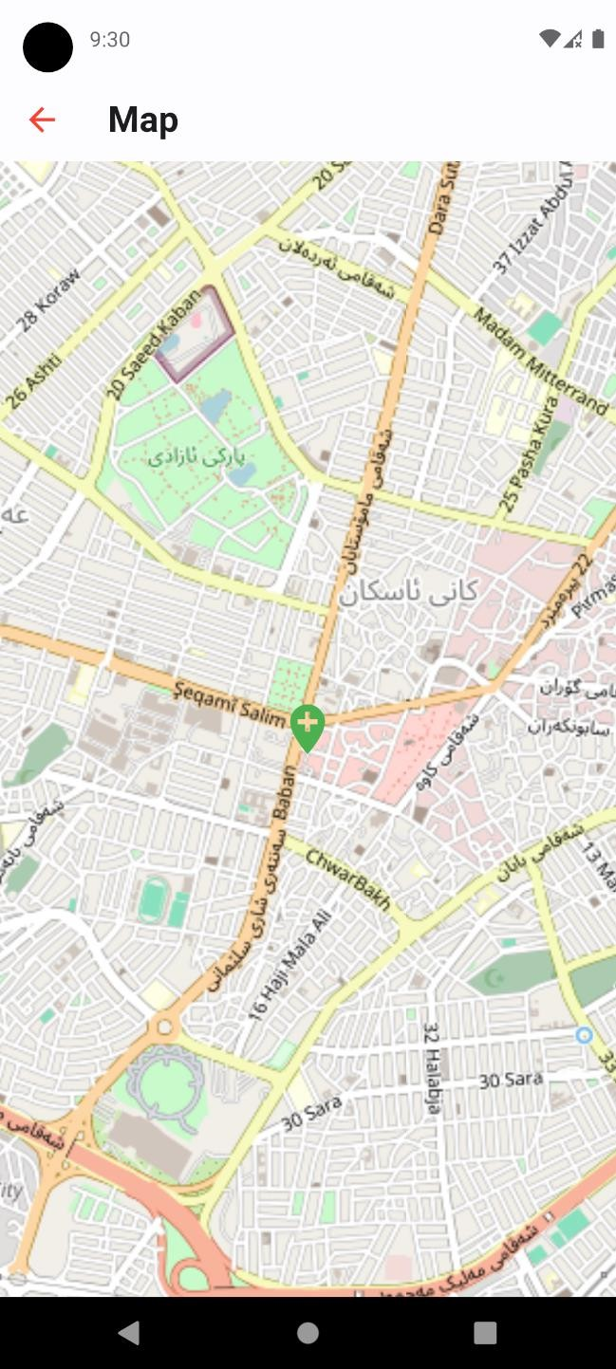
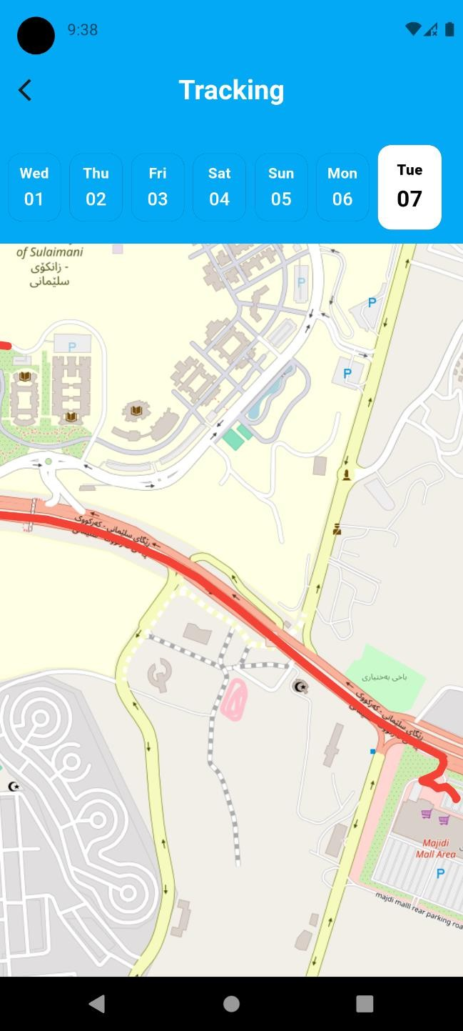
Figure 17: Map interface Figure 18: Tracking Map interface

On the Chat Screen, you can have a one-to-one chat between the parent and child. Chats can also be deleted from the parent option only. Additionally, on the Alert Screen, you can see the most recent alert that was sent from the child's device when the child pressed the danger button.
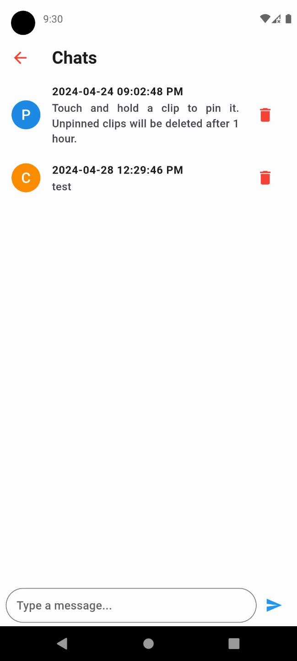
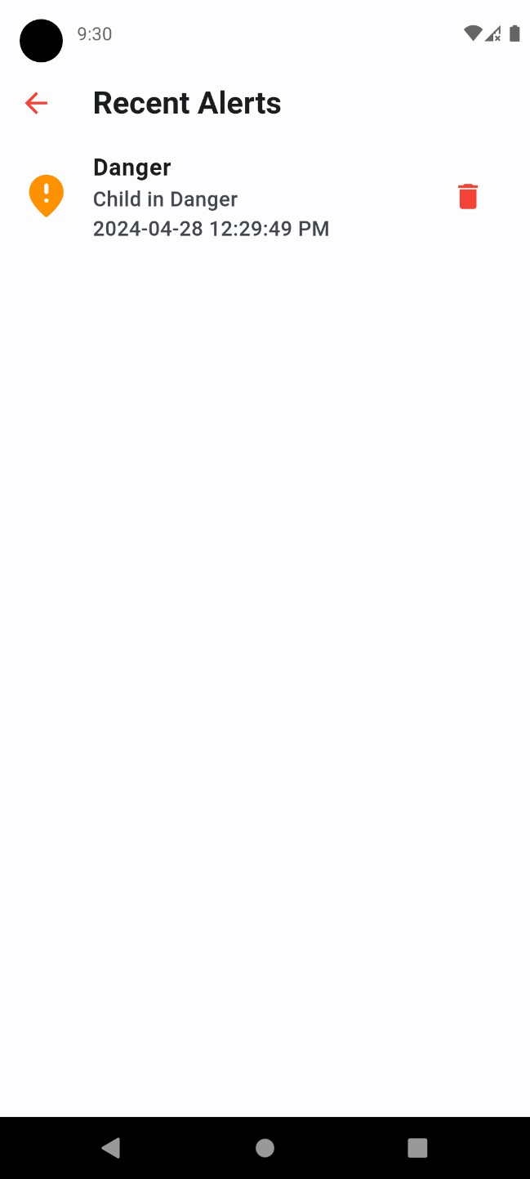
Figure 19: Chat interface Figure 20: Alert Messages interface

The Dashboard of the Child Option contains the following features: 'Set Location' is used if you want access to the device's location; 'Update Location' is used to update your location whenever you want, and it is also auto-updated; the chat feature is for chatting with the parent; and the 'Danger Button' is used to send a message to the parent's device when you are in danger. In the settings of the child option, you must enter a code before you can log out.
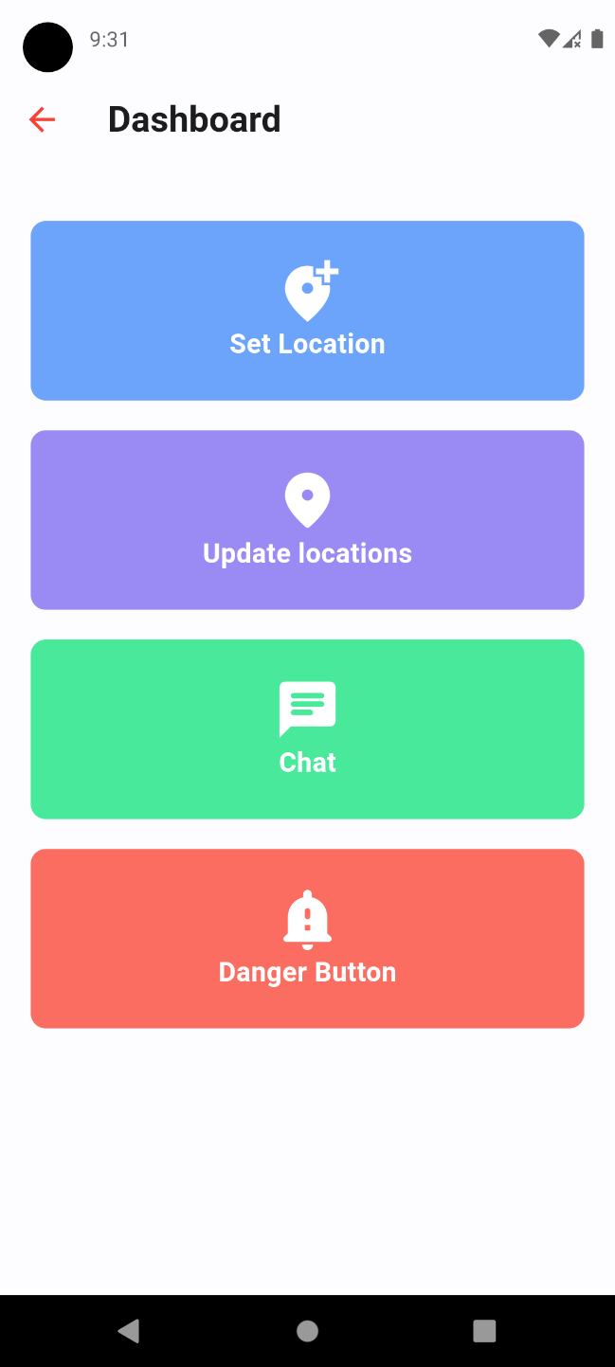
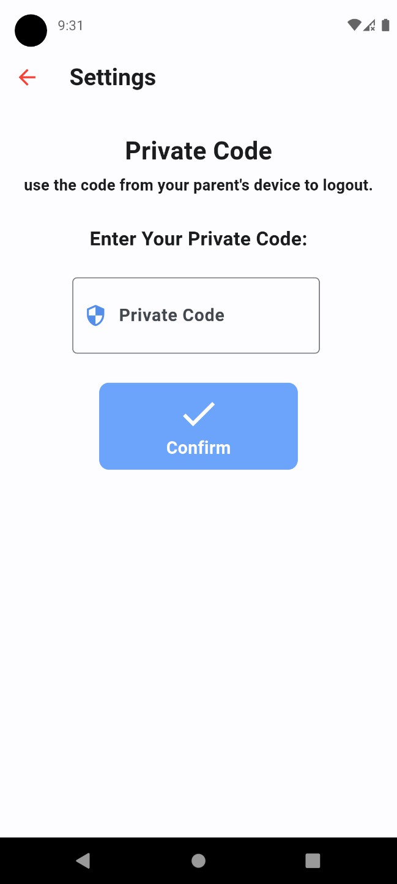
Figure 21: Child Dashboard interface Figure 22: Child Settings interface

Chapter Three Conclusions and Future Directions

  - Introduction

Chapter 3

Conclusions and Future Directions

The conception and the execution of the suggested system have been deliberated in the preceding section. This segment aims to wrap up the document, with an additional focus on the prospective refinement of the proposed system, henceforth, the forthcoming endeavors will also be examined.

Conclusions
This project entitled (Child Guard and Tracking Location,) using Flutter framework for its interface design (front-end) and utilizes cloud Firebase for the database (back- end). It's versatile, operating seamlessly across Android, iOS, and computers. With a highly intuitive design, it ensures easy navigation for all users. This software provides a guarantee to safeguard children from any perilous situations by showcasing their real-time location and storing tracking data securely. Parents can effortlessly access the tracking information and engage in communication via chat. Moreover, it features a panic button enabling children to instantly connect with their parents in times of danger. The system also includes geofencing capabilities, alerting parents when their child enters or leaves designated safe zones. Future updates aim to integrate with wearable devices, further enhancing the system's reliability and functionality.

Future Directions
In future work, the Child Guard application will focus on integrating advanced geofencing capabilities to create multiple safe zones and provide customized alerts for different areas. Additionally, the development will include compatibility with wearable devices like smartwatches and GPS-enabled accessories for continuous

monitoring. Establishing partnerships with local authorities will be a priority to facilitate quick response and assistance in emergency situations. Furthermore, implementing AI algorithms to analyze movement patterns and predict potential safety risks will offer proactive alerts and recommendations, enhancing the overall safety and functionality of the application.

پوختە

پوختە

ئەم پڕۆژەیەی بەردەستتان پڕۆژەی کۆتایی ئێمەی خوێندکاری کۆتا قۆناغی بەشی زانستی کۆمپیوتەرە لە
(Child Guard: GPS Location Tracking Mobile App) بەناوی پڕۆژەکە سلێمانی زانکۆی
واتە: ئەپێکی مۆبایلە بۆ بەدواداچوونی شوێنی GPS کە بۆ دڵنیابوونی باوک و دایک لە سەلامەتی منداڵ و دابینکردنی ئارامی دەروونی بۆ دایک و باوک و سەرپەرشتیاران دروستکراوە، ئەم بابەتەمان هەڵبژاردووە بۆ دەستەبەرکردنی ڕێگایەک بۆ هاوکاری دایک و باوک لە پەروەردەکردنی منداڵەکەیان، ئەپەکە ڕێگە بە دایک و باوکان دەدات لە ڕێگەی مۆبایلە زیرەکەکانیانەوە شوێنی منداڵەکانیان لە کاتی ڕاستەقینەدا بزانن، وە ئەم ئەپڵیکەیشنە لەسەر بنچینەی فڵەتەر و فایەربەیس دروست کراوە، ئەم ئەپە لە چوار بەشی سەرەکی پێکدێت:
• دۆزینەوە:"Finding" ئەپەکە ئاسانکاری دەکات بۆ دۆزینەوەی شوێنی منداڵ لە کاتی ڕاستەقینەدا لە ڕێگەی شوێنپێهەڵگرتنی جی پی ئێسەوە، زانیاری ورد دەدات بە دایک و باوکان سەبارەت بە شوێنی منداڵەکەیان. تەنها بە چەند لێدانێک، دایک و باوک دەتوانن بە ئاسانی شوێنی وردی منداڵەکەیان دیاری بکەن، ئەمەش ئارامیی دەروونی و دڵنیایی پێشکەش دەکات.

• بەدواداچوون:"Tracking" بەدواداچوونی بەردەوام وا لە دایک و باوک دەکات کە بە درێژایی ڕۆژ چاودێری جوڵەی منداڵەکەیان بکەن دایک و باوکان هەرکاتێک منداڵەکەیان دەچێتە ناو شوێنە دیاریکراوەکانەوە یان دەردەچن ئاگادارکردنەوە وەردەگرن، ئەمەش ڕێگە بە چاودێریکردنی چالاکانە دەدات.

• Database :Firebase بەکاردەهێنێت کە پلاتفۆرمێکی بەهێزی بنکەدراوەیە بۆ هەڵگرتنی زانیاری شوێن و چالاکییەکان بە شێوەیەکی پارێزراو، ئەمەش دڵنیای دەدات لەوەی کە زانیارییەکان بۆ ماوەی ٨ ڕۆژ بۆ دایک و باوکان دەستڕاگەیشتن دەمێننەوە، ئەمەش بەسوودە لەو کاتانەی کە باوکان و باوکان کاتیان نابێت سات بە سات ئاگاداری شوێنی منداڵەکەیان بن.

• دوگمەی فریاگوزاری لەگەڵ چاتکردنChatting" with Button Emergency :" لە حاڵەتی
فریاگوزاریدا، ئەپەکە دوگمەی تایبەتی ترس و دڵەڕاوکێی هەیە کە دەستبەجێ دایک و باوک ئاگادار دەکاتەوە و ڕووکارێکی چات دەستپێدەکات، ئەمەش ڕێگە بە پەیوەندی خێرا دەدات لە نێوان منداڵ و
دایک و باوک یان سەرپەرشتیاران، ئاگادارکردنەوە لە هەر بار ودۆخێکی نەخوازراو و چاتینگ بۆ
نموونە رفاندنە یاخود دەستدرێژی کردن.

Bibliography
- A. Alexander, "Smartphone Usage Statistics 2012," Anson Alexander. [Online]. Available: http://ansonalex.com/infographics/smartphone-usage-statistics-2012-infographic/. [Accessed: 12-May- 2024].
- P. Michaels, "Best GPS tracker for kids in 2024," Tom's Guide. [Online]. Available: https://www.tomsguide.com/us/best-gps-child-trackers,review-2884.html. [Accessed: 12-May-2024].
- C. Woods, "What is real-time GPS tracking," Locate2U. [Online]. Available: https://www.locate2u.com/author/chelsea/. [Accessed: 12-May-2024].
- E. Lee, "The Best Ways to Track Your Kid," The New York Times. [Online]. Available: https://www.nytimes.com/wirecutter/blog/best-ways-to-track-your-kid/. [Accessed: 12-May-2024].
- Cyber Travel Tips, "Statistics of Missing Child in Malaysia," The Cavell Group. [Online]. Available: http://www.thecavellgroup.com/. [Accessed: 12-May-2024].
- K. Michael, A. McNamee, and M.G. Michael, "The Emerging Ethics of Humancentric GPS Tracking and Monitoring," IEEE Xplore. [Online]. Available: https://ieeexplore.ieee.org/abstract/document/4124129. [Accessed: 12-May-2024].
- S. Manoharan, "On GPS Tracking of Mobile Devices," IEEE Xplore. [Online]. Available: https://ieeexplore.ieee.org/abstract/document/4976795. [Accessed: 12-May-2024].
- H. A. A. Dafallah, "Design and implementation of an accurate real time GPS tracking system," IEEE Xplore. [Online]. Available: https://ieeexplore.ieee.org/abstract/document/6991376. [Accessed: 12-May- 2024].
- S. Korpilo, T. Virtanen, and S. Lehvävirta, "Smartphone GPS tracking—Inexpensive and efficient data collection on recreational movement," ScienceDirect. [Online]. Available: https://www.sciencedirect.com/science/article/abs/pii/S0169204616301578. [Accessed: 12-May-2024].
- G. Rajendran, M. Arthanari, and M. Sivakumar, "GPS Tracking Simulation by Path Replaying," IJITCE. [Online]. Available: http://ijitce.co.uk/download/january/ijitce_jan4.pdf. [Accessed: 12-May-2024].
- N. C. Soe, T. L. L. Thein, and T. Aung, "GPS Tracking and Traffic Monitoring System in Urban Transportation," IEEE Xplore. [Online]. Available: https://ieeexplore.ieee.org/abstract/document/8574509. [Accessed: 12-May-2024].
- C. Igwenagu, Fundamentals of research methodology and data collection, Enugu State University of Science and Technology, Enugu State, Nigeria, 2016. [Online]. Available: https://www.researchgate.net/publication/303381524_Fundamentals_of_research_methodology_and_d ata_collection
- M. L. Despa, "Comparative study on software development methodologies," Database Systems Journal, vol. 5, no. 3, pp. 37-56, 2014.
- P. Pedamkar, "EDUCBA," 1 March 2021. [Online]. Available: https://www.educba.com/iterative- [Accessed: 13-May -2024].1`

- Airbrake, "Iterative Model: What Is It And When Should You Use It?," 2016. [Online]. Available: https://airbrake.io/blog/sdlc/iterative-model. [Accessed: 13-May -2024].
- Amazon Web Services, 'What is a Database?' AWS. [Online]. Available: https://aws.amazon.com/what- is/database/. [Accessed: 13-May -2024].
- Back4App, 'What Is Cloud Firestore,' Back4App Blog. [Online]. Available: https://blog.back4app.com/what-is-cloud-firestore/. [Accessed: 13-May -2024].
- 'Programming Languages,' Codecademy. [Online]. Available: https://www.codecademy.com/resources/blog/programming-languages/. [Accessed: 13-May -2024].

- 'Flutter - Dart Programming,' JavaTpoint. [Online]. Available: https://www.javatpoint.com/flutter- dart-programming. [Accessed: 13-May -2024]
- 'Visual Studio Code,' Wikipedia. [Online]. Available: https://en.wikipedia.org/wiki/Visual_Studio_Code. [Accessed: 13-May -2024]

- 'Why Flutter is the most popular cross-platform mobile SDK,' Stack Overflow Blog. [Online]. Available: https://stackoverflow.blog/2022/02/21/why-flutter-is-the-most-popular-cross-platform-mobile-sdk/#h2- 00081930f0980. [Accessed: 13-May -2024].
- 'What is OpenStreetMap,' OpenStreetMap Welcome Page. [Online]. Available: https://welcome.openstreetmap.org/what-is- openstreetmap/#:~:text=OpenStreetMap%20is%20a%20free%2C%20editable,that%20was%20free%20to
%20use. [Accessed: 13-May -2024].
- B. H. Dennis, W. Wixom, and D. Tegarden, Systems Analysis and Design: An Object-Oriented Approach with UML, 5th ed. Wiley, 2015.

